KEY TOOLS PORTFOLIO FOR SERVITIZATION OF CE PRODUCT-BASED MANUFACTURING COMPANIES

Phase 1 - revised

|  |  |
| --- | --- |
| **D.T3.2.5** | **Version 1**  **03 2019** |

THINGS+

Introducing service innovation into product-based manufacturing companies

01.06.2017 - 31.05.2020

Project number: CE 988

Interreg Central Europe Programme

|  |  |  |  |  |  |
| --- | --- | --- | --- | --- | --- |
| Work package | T3 | Activity | A.T3.2 | Deliverable | D.T3.2.5 |
| Date | March 26th 2019 | | | Due date | March 2019[1] |
| Title | Key tools portfolio for servitization of CE product-based manufacturing companies – Phase 1 | | | | |
| Project Partner responsible | All partners | | | | |
| Report Status (DR = Draft, FI = Final) | | | | FI | |
| THINGS+ website | http://www.interreg-central.eu/Content.Node/THINGS-.html | | | | |

Contents

1. Phase 1: Opportunities based on existing capabilities and knowledge – inside-out 2

1.1. Product and service list 4

1.2. Past strategies list 6

1.3. Product attributes map 9

1.4. Main customer problem “as is” – main customer jobs (JTBD - job to be done) 13

1.5. Value Proposition Canvas – part 1 15

1.6. Value Proposition Canvas – part 2 18

1.7. List of alternatives (competitors, substitutes, workarounds) 21

1.8. List of relevant services on the market 23

1.9. Strategy canvas for „the problem” 25

1.10. Opportunities brainstormed (Four actions framework) 28

1. Phase 1: Opportunities based on existing capabilities and knowledge – inside-out

This document contains the tools and methods to be used during the first phase of the Service Innovation Methodology implementation in manufacturing SMEs. The first phase deals with assessment of the company capabilities, existing products and services features and competition actors. During this first phase the company will start to conceptualise its opportunities for servitization based on the capabilities and knowledge that are concentrated within the organisation itself. This phase includes a workshop with SMEs’ employees where some of the tools will be used in collaboration with the expert personnel from the consortium. The main outputs from the first phase are the potential opportunities that arise from the “inside-out” assessment of company’s capabilities, existing offer and position on the market.

The workflow of the first phase is presented in the following scheme.

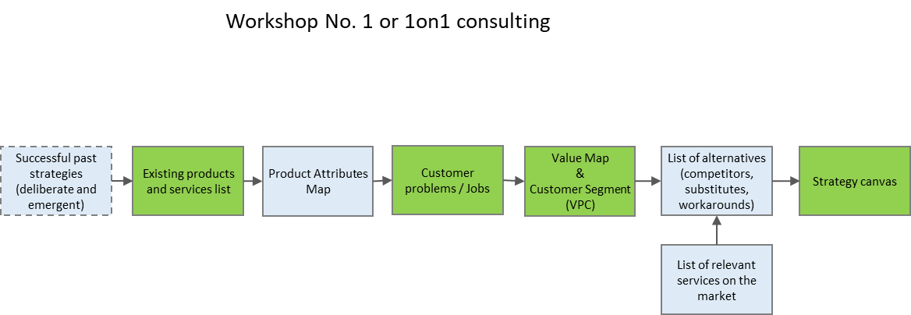

Figure 1 Workflow of the first phase of the Service Innovation Methodology

* 1. Product and service list

|  |  |
| --- | --- |
| **The starting point of Service Innovation Methodology implementation is to document all the company’s products and services already present on the market in order to evaluate their importance for the company and potential for enhancement through servitization. In the context of THINGS+ project, this form might be filled out and submitted after the particular application for Pilot Actions was accepted.**  **Otherwise, it can be conducted as initial “orientation” activity at the beginning of the very first joint event of the pilot group as a part of their introduction to other participants.** | |
| **Guidelines on implementation:** | **D.T1.3.1 - Phase 1 – Application / Introduction event or the first workshop** |

It is a tool that aims to document existing products (and appropriate services) that company already has. Can be used either as initial content from the application or at the beginning of the servitization process. The idea is to document and rank importance of existing products.

Products are assessed from the perspective of:

* **Financial relevance** for the company (1-low relevance; 5-critical, highest relevance). Aim is to rank products based on overall income and profitability.
* Second criteria is **perceived importance** – some products, especially newly developed products or products based on advanced technologies that are not positioned well might have higher importance for company brand and future position on the market.
* Resulted **impact** is multiplication of both perspectives and ranking might be used as suggestion of the most promising products for servitization.

|  |  |  |  |  |
| --- | --- | --- | --- | --- |
| **Product/service** | **Description** | **Financial relevance**  **(1 min – 5 max)** | **Perceived importance**  **(1 min – 5 max)** | **Impact**  **(financial x perceived)** |
|  |  |  |  |  |
|  |  |  |  |  |
|  |  |  |  |  |
|  |  |  |  |  |
|  |  |  |  |  |
|  |  |  |  |  |
|  |  |  |  |  |
|  |  |  |  |  |

* 1. Past strategies list

|  |  |
| --- | --- |
| **An analysis that evaluates the capabilities of the company is the analysis of past successful and unsuccessful strategies that the company adopted. Formal or informal successful strategies are a significant indicator of company’s competences and possibilities to develop, especially if previous strategies included elements of service innovation.**  **Underlying idea is to, if possible, during servitization development and implementation mostly use strategies that worked well in the past.** | |
| **Guidelines on implementation:** | **D.T1.3.1 - Phase 1 – Application or first workshop** |

Purpose of creating the strategies list is to identify core competences of a company and business circumstances under which the company can be successful. Previous successful strategies and company’s successes in general are objective measure (or proof) of company’s capabilities. Formal strategy or decision to pursue particular strategy was often not enough. To successfully implement chosen strategy, company had to show competence for chosen customers and markets, competing environment and value proposition. Therefore, successes are direct result of core competences of a particular company.

Formal existence of paper called “strategy” is not prerequisite, in some occasions even not relevant. Plain and simple description of “our way” is what is needed in the process of servitization in manufacturing SMEs, where “implemented” real life strategies are a confirmation of company’s capabilities, instead of “intended” ones and wishful thinking.

**Deliberate strategies** are those where the collective vision, goals and intentions of an organization, mostly determined by its leadership, are articulated and communicated to the actors/employees (responsible for implementation) within that organization in order to realize a given outcome. These strategies are planned and imposed, therefore it can be argued that this approach has the advantage of clarity of purpose as opposed to emergent strategies. In this case, the intentions of management are clear and explicit therefore easier for all the actors within the organisation to understand and work towards defined goals. On the other hand, this approach has its disadvantages, because when being fixated on a specific outcome may increase an organizations rigidity and lower its speed of responsiveness in the event of changes in their operating environment or negative feedback received from the pursuit of a particular strategy.

**Emergent strategies** are those where consistencies arise in the actions and behaviour of an organization over a period of time, even though their adoption was never explicitly intended. This can occur when an environment directly imposes a pattern of actions on an organization. These strategies are much more flexible and responsive opposed to deliberate strategies. They emerge through patterns or consistent stream of actions as a result of influences such as the environment, positive feedback or consistent success of particular action; there is no clearly spelt out intention from a central leadership and as such, a key advantage of emergent strategies such as unconnected or consensus strategies is that they offer a degree of flexibility or responsiveness which is absent in deliberate strategies. Organisations are able to adjust their patterns in reaction to realized outcomes of their present actions.

For each strategy stated in the provided form, there should be described the markets where success was eventually achieved, targeted customer segments, relationships with competition, distribution network and channels, methods of company development and scaling up. This information should answer the questions “Where the company wins?” and “How the company wins?”.

Besides being the proof of company’s competences, described strategies also define the value system of the organisation. Successful past strategies often limit future choices and decisions because companies tend to continuously perform activities the same way those have been done so far, with as little disruption as possible.

|  |  |
| --- | --- |
| **Additional sources:** | * <http://open.lib.umn.edu/strategicmanagement/chapter/1-3-intended-emergent-and-realized-strategies/> * <https://www.linkedin.com/pulse/20140630061420-296333353-deliberate-vs-emergent-business-strategy> |

|  |  |  |
| --- | --- | --- |
| **Past strategies list** | | |
| **Successful deliberate** | **Successful emergent** | **Unsuccessful** |
|  |  |  |

* 1. Product attributes map

|  |  |
| --- | --- |
| **The initial identification of opportunities for servitization starts with unveiling the hidden knowledge within the organisation and the shift of the perspective – from “product centricity” into “customer centricity”. In order to clarify the offer (product and service bundle) and start the transformation of perspective, the Product attributes map should be used to identify key features of the offer that could be categorized based on how customers perceive them.**  **Although Product attributes map has quite “product centric” feeling it is a good starting point for the gradual shift of the perspective from product to customer related issues.** | |
| **Guidelines on implementation:** | **D.T1.3.1 - Phase 1 – Workshop** |

Product attributes map is a tool used to track and evaluate a dynamic fit between the needs of the customer segments and the attributes of the product but it can also be used prospectively to plan new products or service and to help a company screen for desirable customer segments.

After uncovering salient product attributes, these are mapped onto the ACE Matrix (Attribute Categorization and Evaluation), which is a grid that highlights the competitive imperatives for each attribute. It helps focus attention on opportunities to use the company’s distinctive skills to create new exciters and differentiators or to turn competitors’ tolerables into dissatisfiers. Thus, the attribute matrix enables to define what action a company must take in response to each attribute, therefore helps structure a more strategic assessment of a product and its future.

The method is used through several steps:

* **Uncovering Salient Attributes** – Identifying parallel needs, identifying purchasing patterns, observing how customers actually use the product, identifying customers’ perceptions of risk
* **Mapping the Attributes** - Each cell of the matrix has a distinctive impact on the competitiveness of the product (basic, discriminator, energizer). Mapping is performed through following steps:
  + Determining the specific customer segment(s) to target.
  + **The top row** shows those features and attributes that customers regard as Positive; they might prompt them to buy and stay loyal to your products or service. Basic Features (the first column) are those that the targeted segment expects to receive. They’re non-negotiable and often not an object for investment since customers usually take it for granted. Positive Discriminators, in the middle column, help to differentiate and give a competitive position. Here the basis can be formed for competitively differentiated pricing and positioning. In the Energizers column are the most positive attributes which distinguish organisation from its competitors and give customers a highly motivating reason to buy and use its offering.
  + In **the middle row** are Negatives: things that customers dislike and would rather do without. Tolerables, in the first column, are expected by the customer and won’t affect whether they buy from the organisation or one of the competitors. Great competitive advantage can be gained through eliminating a tolerable. Negative Energizers, in the third column, inspire a range of negative emotions which emerge as a result of misjudgment, such as a launch of a product or service perceived as unacceptable. It is critical to eliminate these quickly.
  + In **the third row** are Neutral attributes that customers either don’t care about or don’t even know about. To complete the Neutral row, customer segment should be considered carefully. What is neutral to some customers can be considered basic or differentiating to others. In general, neutrals add cost without enhancing value and eliminating them can drive down both cost and price.
* **Validation** - Once a company has mapped out its assumptions about how its customers react to the product, it must validate those assumptions. A variety of focused market research techniques can test the accuracy of the initial mapping: focus groups, discussions with lead customers and distributors, and test markets. It should be considered: how can positive attributes be delivered faster, better, cheaper, and more conveniently than now? How might negative and neutral attributes be reduced or removed? How can new needs that customers may be developing be met?
* **Continuous Reconfiguration** - After using the ACE matrix to test assumptions, a company can use it to anticipate attribute migration. As customers and competitors become familiar with the product attributes, those attributes will migrate from one cell in the matrix to another.

|  |  |
| --- | --- |
| **Additional sources:** | * <https://hbr.org/1996/05/discover-your-products-hidden-potential> * <https://executiveeducation.wharton.upenn.edu/thought-leadership/wharton-at-work/2012/06/attribute-map-1> * <https://executiveeducation.wharton.upenn.edu/thought-leadership/wharton-at-work/2012/07/attribute-map-2> |

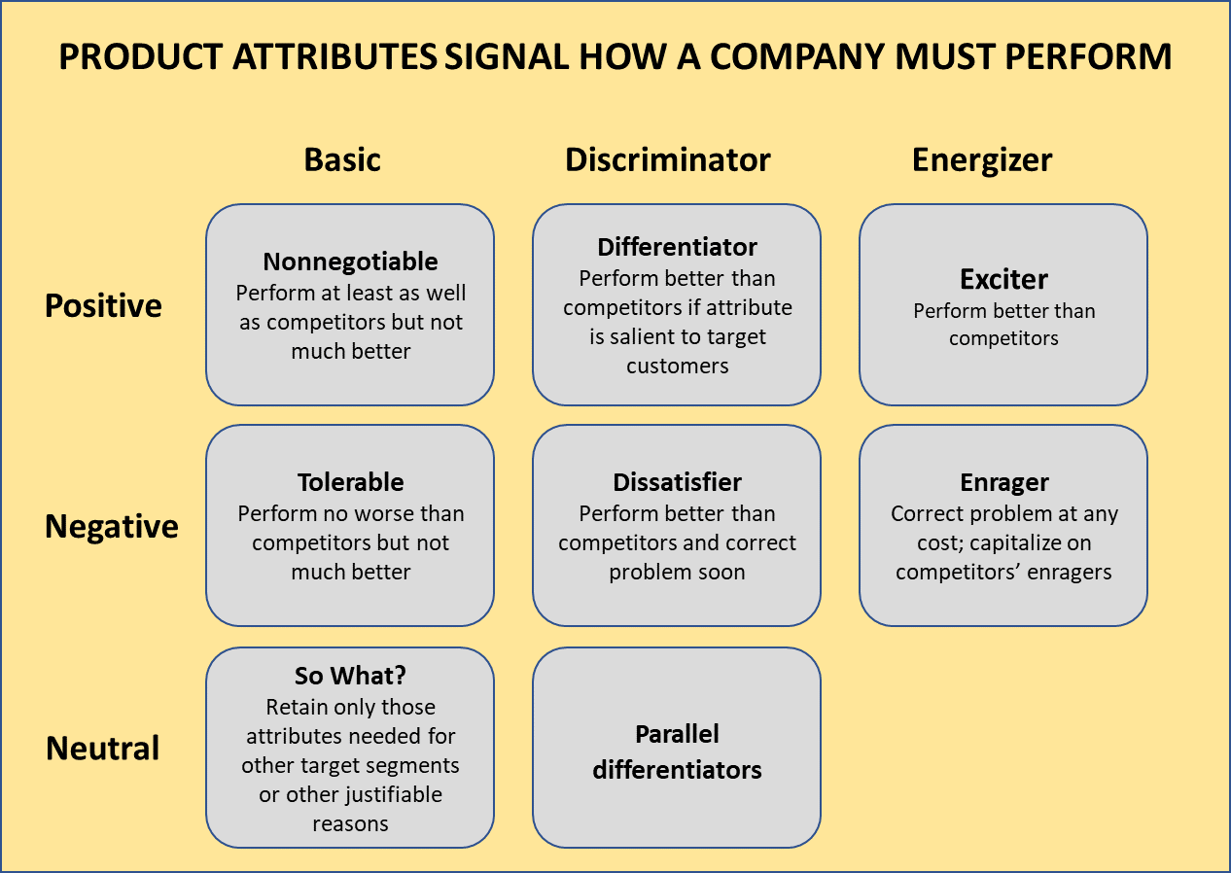

|  |  |  |  |
| --- | --- | --- | --- |
|  | Basic | Discriminator | Energizer |
| Positive |  |  |  |
| Negative |  |  |  |
| Neutral |  |  |  |

* 1. Main customer problem “as is” – main customer jobs (JTBD - job to be done)

|  |  |
| --- | --- |
| **Definition of the main customer problem(s) shifts perspective to targeted customer segment for which the company aims to develop service.** **Those customers are not necessarily final users for chosen product – intended services might be targeted to intermediaries in the distribution chain – wholesalers or retail segments. Various but clearly targeted and well-defined customers have to be in mind when doing this step.** **Suggested technique is to choose particular real person that “represent” particular customer segment.**  **The company needs to be focused on the problem that this person is trying to solve (the Job to Be Done concept).**  **Customer problems/Jobs and buying/using circumstances are of paramount importance for future SIM activities, therefore this activity is of critical importance!** | |
| **Guidelines on implementation:** | **D.T1.3.1 - Phase 1 – Workshop** |

Starting point for better customer understanding is the unfolding of the real reasons for their relationship with the company and its products.

Main task of this tool is to introduce the customer perspective into understanding of the company’s market. Instead of product and market segmentation based on the products, starting point should be customer problems (goals) and market segmentation based on the customer circumstances and problems (goals) that appear within those circumstances.

This is a condensed tool that allows descriptions of the three interrelated topics related to chosen product/offering:

* **Customers: Who the customers are?**Describe people that buy or use the product, which could be defined as individual persons, professionals, family or any other social group members.
* **Reasons for buying the product: Why do the customers buy or use our product?**Describe how is the product used to solve a problem that occurs in customer’s life or enable customer to achieve something, improve living conditions or avoid unwanted outcomes and consequences.
* **Circumstances: When and (sometimes) where customers buy and use our products?**Circumstances define behaviour of the customer groups – size of the market is not limited by the number of the customers but by the occurrence of the favourable circumstances for the company’s product.

|  |  |
| --- | --- |
| **Additional sources:** | * <https://hbr.org/2016/09/know-your-customers-jobs-to-be-done> * <https://strategyn.com/jobs-to-be-done/> * <https://jobs-to-be-done.com/define-the-market-around-the-customers-job-to-be-done-49b65324e5bd> |

|  |  |  |
| --- | --- | --- |
| **Product**: | | |
| Customer segment  (buyer or user)  **Who is our customer?** | Problem or “job to be done”  **Why customers buy/use?** | Buying/using circumstances  **When customers buy/use?** |
|  |  |  |
|  |  |  |
|  |  |  |

* 1. Value Proposition Canvas – part 1

|  |  |
| --- | --- |
| **Product attributes identified in previous tool are useful inputs for the elaboration of the first part of the Value Proposition Canvas. The aim of using this tool is to further formulate product/service (use it to get more focused description of integrated single offering) and distinct features from the perspective how they influence customer.**  **Within the company, features of the product are often perceived as technical or technological challenges, while this tool helps to shift that perspective into the functional and utilitarian customer-centric perspective.**  **Main purpose of Value Proposition Canvas is to transform previously defined product features into customer perceived benefits – through created “gains” or avoided or reduced “pains”. Secondly, it allows start of learning that product features that are not transformed to customer perceived benefits might be useless and not needed anymore.** | |
| **Guidelines on implementation:** | **D.T1.3.1 - Phase 1 – Workshop** |

Value Map helps to make the value proposition visible and tangible. It is a part of the Value Proposition Canvas which is often used in combination with the Business Model Canvas. Value Map is used to define the features of the company’s products and services that relieve pains and resolve difficulties that arise from performing the Job To Be Done and also bring benefits to the customer. These features describe how is the value proposition for the customers created. Defining these features, using the Value Map, helps to project, test and build the business value proposition in a more structured way. It allows testing and iterating a product-service concept based on constructive teamwork and analysis of assumptions about customers and market.

In the box named **Products & Services**, it should be defined all the products and associated services around the value proposition is built around. These can be tangible, intangible, digital, financial, etc., and they all don’t have the same relevance to the customer. Those which are essential to the value proposition should be distinguished from those which are less relevant.

In the box **Pain relievers**, it should be addressed how the product service system addresses the difficulties, needs and pains of the customers. These statements should explicitly outline how the company intends to eliminate or reduce difficulties that customers meet before, during or after the job they are trying to accomplish, or even those that prevent them from performing the job. Pain relievers also should be differentiated by relevance, because they address difficulties of different importance. The larger is the issue that they solve, the larger is the value they create.

In the **Gain creators** box, it should be described how the company’s product-service system help customers achieve gains or how it offers value to the customer. Here it should be outlined how the company intends to produce outcomes and benefits that the customer expects and desires, consciously or not consciously. The Gain creators also need to be differentiated so the focus can be kept on those that are the most relevant for the customer.

While mapping value creation, the defined elements and listed statements should be those that have the most relevance to the customer because it would be unrealistic to address all of the jobs, pains and gains of the customer. Products and services listed should be those that form value proposition for a specific customer segment while the gain creators and pain relievers address the essential customer gains and extreme customer pains. Products and services, pain relievers and gain creators must address those jobs, pains and gains that are stated in the other part of the Value Proposition Canvas, and that is the Customer Profile.

|  |  |
| --- | --- |
| **Additional sources:** | * Osterwalder, A.; Pigneur, Y.; Bernarda, G.; Smith, A.: Value Proposition Design, John Wiley and Sons, Inc., Hoboken, New Jersey, USA, 2014 * <https://strategyzer.com/canvas/value-proposition-canvas> * <https://medium.com/upperstory/the-flow-of-a-value-proposition-canvas-b63b68f0e28b> * <https://www.peterjthomson.com/2013/11/value-proposition-canvas/> |



Figure 2 Value Map – part of the Value Proposition Canvas (source: <https://strategyzer.com/>)

* 1. Value Proposition Canvas – part 2

|  |  |
| --- | --- |
| **Customer Profile is the other side of the value Proposition Canvas. The aim of this tool is to assist with formulation of preferences of the particular customer segment and the problem for which this customer segment is looking for solution. Gains that customers obtain for particular “job to be done” should be described along with the pains that come with it.**  **This is pure customer perspective, so it is crucial to be careful not to mirror “Value Map” – one should look for the differences and what doesn’t fit after the customer perspective is described with the Customer Profile.** | |
| **Guidelines on implementation:** | **D.T1.3.1 - Phase 1 – Workshop** |

When defining the value proposed with the offering of the product-service system, it is important to define the job that the customer is trying to get done. Furthermore, its needed to define what pains and difficulties the customer meets while performing that job. These elements can be described using the Customer Profile map which is a part of the Value Proposition Canvas.

The first segment that needs to be defined is the **Customer Jobs**. Here should be described the things that the customer is trying to get done, being different tasks trying to be performed and completed, problems trying to be solved or need trying to be satisfied. It is important to take the customer’s perspective while defining those jobs to identify what is they are actually trying to get done.

There are three main types of jobs: **Functional jobs** – performing a specific task or solving a specific problem; **Social jobs** – jobs performed to give impression or define how to be perceived by others (look trendy, perceived as competent); **Personal/emotional jobs** – customers seeking a specific emotional state, such as feeling good or secured.

Customers are also performing supporting jobs while purchasing and consuming value. Depending on the role, these are: **Buyer of value** – jobs related to buying value (comparing, deciding), **Cocreator of value** – jobs related to co-creating value with the organisation (e.g.: posting product reviews, participating in the design); **Transferrer of value** – jobs related to the end of a value proposition’s lifecycle (cancelling service, disposing or transferring a product, reselling).

When defining the job, it is very important to define the context in which it is performed (using phone in a car or in a train) and the importance that it presents to the customer so the focus can be maintained on the relevant ones.

The next segment deals with customer **Pains.** Pains aredifficulties oranything that annoys the customer before, during and after trying to perform the job to be done, or something that prevents them from doing it. Three types of customer pains can be identified: **Undesired outcomes, problems and characteristics** – functional (not working), social (looking bad), emotional (feel bad) and ancillary (annoying); **Obstacles** – they prevent customers from performing a job or slow them down; **Risk (undesired potential outcomes)** – possibility of something go wrong and have significant negative consequences. Pains should be differentiated based on the significance to the customer.

The last segment of the Customer Profile are the **Gains**. Those are outcomes and benefits that the customers want, consciously or not consciously.

Gains can be **Required** (without them solution wouldn’t work), **Expected** (expected, even if the solution works without them), **Desired** (gains that go beyond what is expected from a solution, but customer desires them) and **Unexpected** (gains that go beyond customer expectations and desires).

Jobs, Pains and Gains should be described as precisely and concretely as possible so they can be differentiated from one another and ranked, so the most relevant ones (that customers really care about) can be elaborated.

|  |  |
| --- | --- |
| **Additional sources:** | * Osterwalder, A.; Pigneur, Y.; Bernarda, G.; Smith, A.: Value Proposition Design, John Wiley and Sons, Inc., Hoboken, New Jersey, USA, 2014 * <https://strategyzer.com/canvas/value-proposition-canvas> * <https://medium.com/upperstory/the-flow-of-a-value-proposition-canvas-b63b68f0e28b> * <https://www.peterjthomson.com/2013/11/value-proposition-canvas/> |



Figure 3 Customer Map – part of the Value Proposition Canvas (source: <https://strategyzer.com/>)

* 1. List of alternatives (competitors, substitutes, workarounds)

|  |  |
| --- | --- |
| **After the customer problem, and not the product itself, is defined as the reason for establishing relationship with the customer, it can become the key defining element of the market. Market segment should be defined by the problem that particular products and services are solving. This concept redefines the market perception and introduces new and unconventional competitors that should be identified and documented in the provided form.**  **Main goal is to expand perspective of the companies about their potential target markets. Very often, servitization initiatives aim to unlock previously ignored or underserved markets which were not manufacturing companies core markets.** | |
| **Guidelines on implementation:** | **D.T1.3.1 - Phase 1 – Workshop** |

New technologies and globalisation allowed higher pace of market change resulting in shifting the perspective from the “own industry” focus to the “world of opportunities and threats” point of view. When you define your industry by the problem your product is solving (and not the product itself) it is easy to see how customers are drawn towards different offers from other industries in search of solving the same problem. Once the technology is removed from the industry description (from metal industry to construction solutions, from automobile industry to transportation solutions or from phone industry into connecting people solutions) vast space of both opportunities and threats emerges.

Shifting to offers from other industries can be for traditional reasons like: drawn by the same industry but overseas or developing countries, or attracted to substitute solutions created by the other industries. Sometimes, when product inadequately solves particular customer problem, customers are forced to “invent” some kind of “good enough solution” or find a way to avoid the problem with workarounds. Even “non-consumption” - a decision when customer decide to live with the problem, should be included in the list of the alternatives.

Each of them (competitors, substitutes, workarounds) have a particular “value proposition” – segments that appeal to customers and cause that customers in particular circumstances choose particular solution. Even non-consumption has elements of value proposition: positive (free, simplicity, availability) and negative (problem not solved), and when the positive elements are stronger – the customers won’t buy.

The following form can be used to systematically define and describe the competitors, substitutes and workarounds for a certain job to be done, without being explicitly focused on the same industry.

|  |  |
| --- | --- |
| **Additional sources:** | * <https://hbswk.hbs.edu/item/clay-christensen-the-theory-of-jobs-to-be-done?cid=wk-sm-fb-sf49398184&sf49398184=1> |

**Product: ____________________ Customer problem/JTBD: ______________________**

|  |  |
| --- | --- |
| **Competitors**, substitutes, workarounds | Key elements of its value proposition – why customers choose it. |
|  |  |
|  |  |
|  |  |

* 1. List of relevant services on the market

|  |  |
| --- | --- |
| **Based on the information about the competition’s offerings, companies should identify services offered by competitors and substitutes, and document them in the provided form so the information about them could be used while developing their own services. Aim is twofold – one is to understand (and document) competing offerings on the market, and the second is to identify possible role models that might be used during servitization efforts.** | |
| **Guidelines on implementation:** | **D.T1.3.1 - Phase 1 – Workshop** |

The following table is a simple way to assess and document services provided by the competing companies in order to evaluate opportunities in relation to abilities and performances of other companies doing business in the same market.

|  |  |  |  |
| --- | --- | --- | --- |
| **Name of the service** (and competing company if relevant) | **Brief description of the service**  (When and how is the service delivered? By whom? Which are key resources and activities needed for the service?) | **Objective of the service**  (Answer to which need? Solution to which problem?) | Offered as standard or additional |
|  |  |  |  |
|  |  |  |  |
|  |  |  |  |
|  |  |  |  |

* 1. Strategy canvas for „the problem”

|  |  |
| --- | --- |
| **After assessment of competing alternatives to company’s offer, this tool should be used to visualise the value proposition by evaluating particular elements and factors that define it in relation with the offers of competing companies. Factors that solution providers compete on should be identified and evaluated based on the results of the previous tools, with aim to recognise different opportunities.**  **The result should be a comparison of competing solutions (even they seem incomparable by the traditional product or demographic based market analyses) and understanding of why a particular solution is chosen by the customers under particular customer circumstances.**  **In short, strategy canvas helps to visually understand and predict customer behaviour when particular customer circumstances and (product) offering features are confronted.** | |
| **Guidelines on implementation:** | **D.T1.3.1 - Phase 1 – Workshop** |

Strategy canvas is a diagnostic tool that graphically captures the current strategic landscape and provides visualisation of the future prospects for an organization. It provides a visualisation that might offer new findings when used as a part of a strategic process. It is basically a line graph that plots functions or factors against importance for an organisation and then overlays competitors or industry benchmarks. The strategy canvas serves to capture the current state of the known market space, which allows users to clearly see the factors that the industry competes on and where the competition currently invests. It also propels users to action by reorienting their focus from competitors to alternatives and from customers to noncustomers of the industry.

The horizontal axis on the strategy canvas captures the range of factors that an industry competes on and invests in, while the vertical axis captures the offering level that buyers receive across all of these key competing factors. The value curve or strategic profile is the basic component of the strategy canvas. It is a graphic depiction of a company’s relative performance across its industry’s factors of competition. A strong value curve has focus, divergence as well as a compelling tagline.

The strategy canvas can provide information that allows to formulate a competitive strategy by shifting the strategy focus from competition to alternatives and from customers to non-customers within the industry.

|  |  |
| --- | --- |
| **Additional sources:** | * Kim, W.C.; Mauborgne, R.: Blue Ocean Strategy: Harvard Business School Publishing Coorporation, Boston, Massachusetts, USA, 2015 * <https://www.blueoceanstrategy.com/tools/strategy-canvas/> |

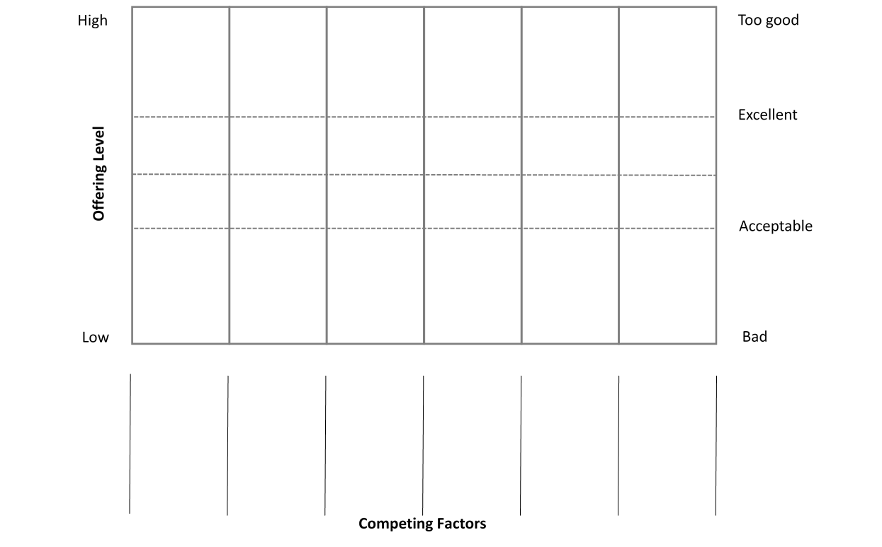

* 1. Opportunities brainstormed (Four actions framework)

|  |  |
| --- | --- |
| **This tool is an addition to strategy canvas and it is to be used for further discussion on possible change and transformation of value proposition in terms of particular factors of competitiveness: should they be reduced, improved, created (added) or even eliminated when creating transformed offer more adapted to particular customer segment.**  **The idea is that “simple” action on particular feature can lead to dramatic change in the perceived and delivered value to the customers and creation of completely new customer groups and markets.** | |
| **Guidelines on implementation:** | **D.T1.3.1 - Phase 1 – Workshop** |

The tool is used to reconstruct buyer value elements during creation of new value curve or strategic profile and it is complementary to the Strategy Canvas. It is based on the Eliminate-Reduce-Raise-Create grid which is a matrix that helps entrepreneurs simultaneously focus on eliminating and reducing, as well as raising and creating new elements while defining new value curve. Brainstorming sessions lead by this tool encourage simultaneous pursue of differentiation and low cost to break the value-cost trade off. It helps to identify if companies are focused only on raising and creating, thereby lifting the cost structure and often over-engineering products and services. The grid is easily understood for different layers of employees and managers creating a high degree of engagement in its application. Completing the grid forces companies to identify every factor the industry competes on, helping them discover the range of implicit assumptions they unconsciously make in competing.

**Eliminate –** It forces companies to consider eliminating factors that companies on a certain industry have long competed on and are often taken for granted even though they no longer have value or may even detract from value. When there is a significant change in what customers value, company often do not act on it, or even perceive the change.

**Reduced –** It forces companies to determine whether the products and services have been overdesigned in the race with competition, when companies overserve customers, increasing their cost structure for no gain.

**Raise** – It encourages companies to uncover and eliminate the compromises that customers are forced to make.

**Create** -helps to discover entirely new sources of value for the customer which can create new demand and even shift the strategic pricing.

Pursuing answers for **Eliminate** and **Reduce** providesinsight on how to drop the cost structure considering competition. **Raise** and **Create** provide answers on how to lift the value for the customer and create new demand. All four actions allow entrepreneurs to systematically explore how to reconstruct customer value elements across alternative industries to offer customers an entirely new experience, while simultaneously keeping the cost structure low.

|  |  |
| --- | --- |
| **Additional sources:** | * Kim, W.C.; Mauborgne, R.: Blue Ocean Strategy: Harvard Business School Publishing Coorporation, Boston, Massachusetts, USA, 2015 * <https://www.blueoceanstrategy.com/tools/four-actions-framework/> * <https://www.blueoceanstrategy.com/tools/errc-grid/> |

|  |  |  |
| --- | --- | --- |
|  | Raise  Which factors should be *raised* *well above* the industry’s standard? |  |
|  |
| Eliminate  Which factors that the industry has long competed on should be *eliminated*? | **New Value Curve** | Create  Which factors should be *created* that the industry has never offered? |
|  |  |
|  | Reduce  Which factors should be *reduced* *well below* the industry’s standard? |  |
|  |

1. The delivery month settled in the approved Application Form (February 2019) has been postponed upon decision of the Project Management Board to improve the quality of the deliverable. The delay did not have any negative effect on the project implementation